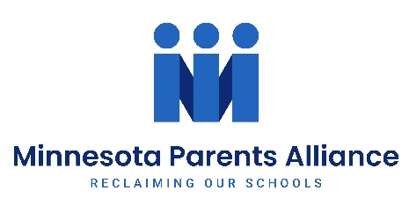
SAMPLE CURRICULUM OPT-OUT NOTICE

Dear Mr./Mrs. (NAME OF TEACHER),

Per Minnesota State Statute 120B.20, I am requesting that my child, (NAME OF STUDENT), is not required to (participate in/access/read/attend - DESCRIBE ELEMENTS OF ASSIGNED CURRICULUM YOU DO NOT WANT YOUR CHILD TO ACCESS/PARTICIPATE IN).
Please contact me at your earliest convenience to discuss alternative materials and instruction for (NAME OF STUDENT) and how my child will receive an equal opportunity to be accessed, graded or awarded credit for the alternative material and instruction that will be used.
I look forward to partnering with you to make sure this request does not cause any miscommunications or unnecessary complications for you or (NAME OF STUDENT).

Thank you,
(YOUR NAME)
(YOUR CONTACT EMAIL AND PHONE NUMBER)

Cc: (NAME OF PRINCIPAL/ADMINISTRATOR)

MN STAT. 120B.20 PARENTAL CURRICULUM REVIEW.
Each school district shall have a procedure for a parent, guardian, or an adult student, 18 years of age or older, to review the content of the instructional materials to be provided to a minor child or to an adult student and, if the parent, guardian, or adult student objects to the content, to make reasonable arrangements with school personnel for alternative instruction. Alternative instruction may be provided by the parent, guardian, or adult student if the alternative instruction, if any, offered by the school board does not meet the concerns of the parent, guardian, or adult student. The school board is not required to pay for the costs of alternative instruction provided by a parent, guardian, or adult student. School personnel may not impose an academic or other penalty upon a student merely for arranging alternative instruction under this section. School personnel may evaluate and assess the quality of the student's work.

